# Windows OS

## Create Batch File to Run the Python Script

The content within the Batch file would follow the following generic structure. The path would varies based on where the file is stored.





Figure 1: Batch File sample

## Schedule the execution of Python Script using Windows Scheduler

Step 1

First, open the Control Panel and then click on the **Administrative Tools**:

Admin Tools

While for Windows 10 user, Search up for Computer Management:

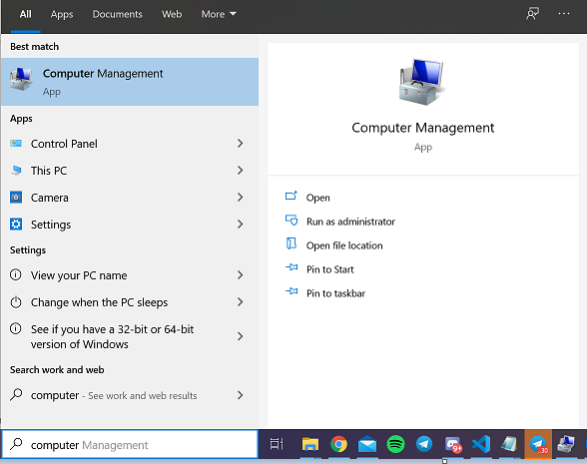

Step 2

Next, double-click on the **Task Scheduler**, and then choose the option to *‘Create Basic Task…’*

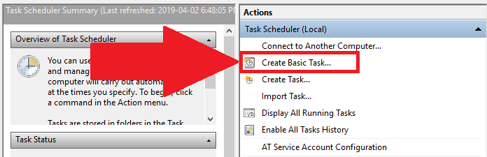

Step 3

Type a name for your task (you can also type a description if needed), and then press Next.

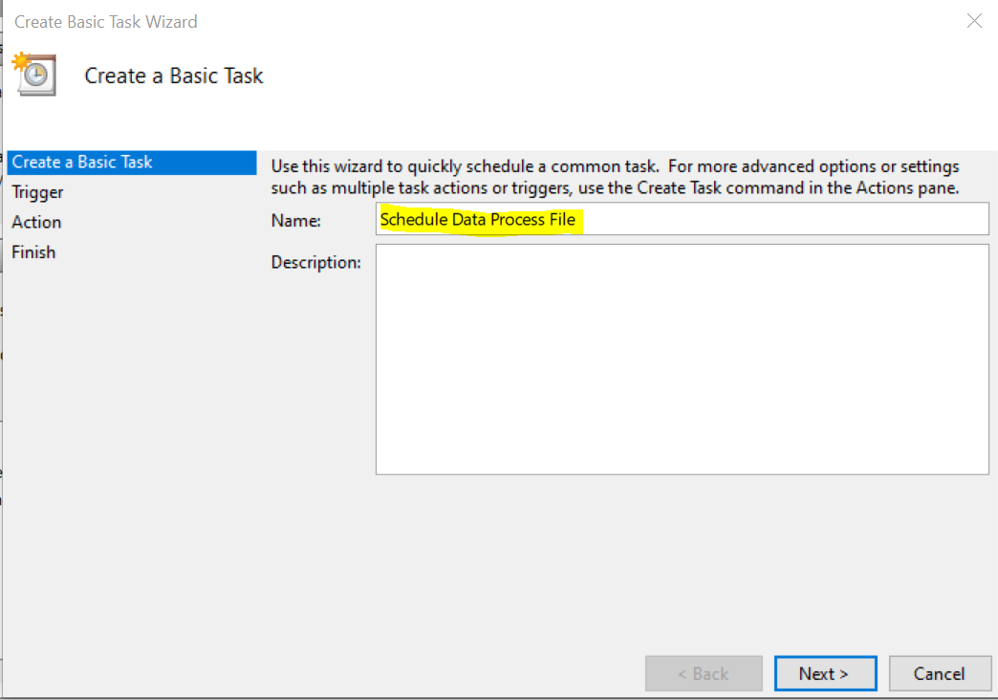

Step 4.1

Next, I chose to start the task ‘Daily’ since we wish to run the Python script daily at **1am**:

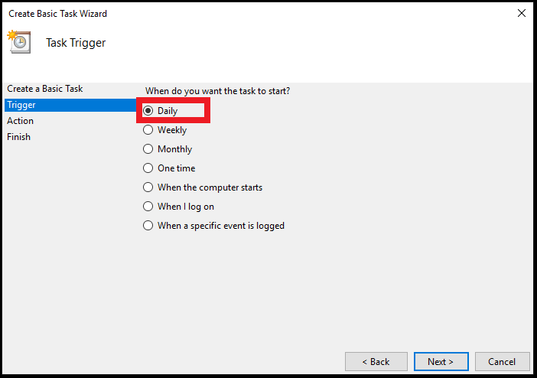

Step 4.2

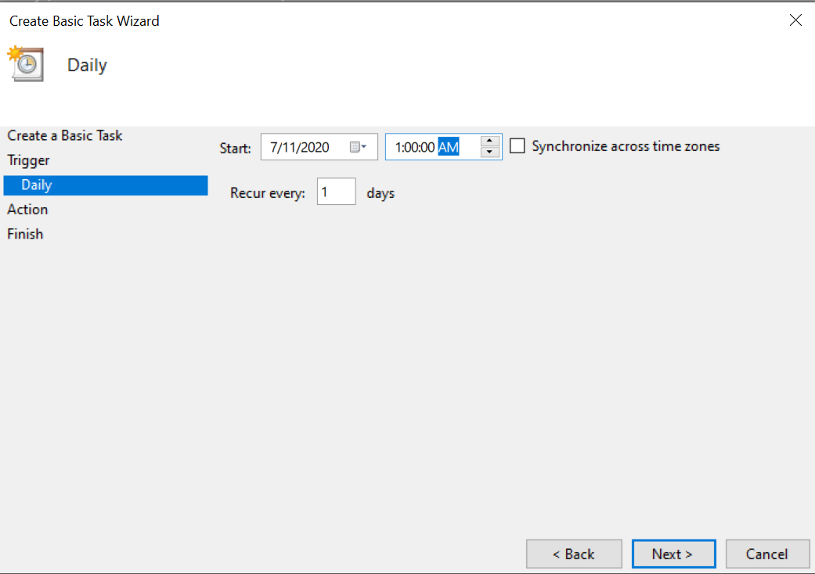

Step 5

Select, **Start a program**, and then press Next:

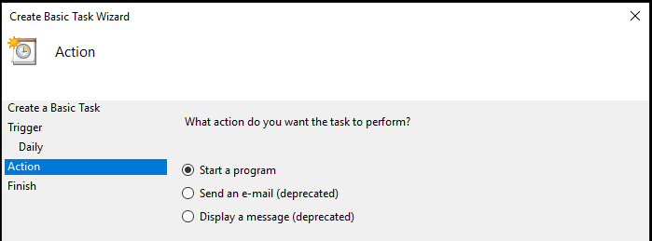

Step 6

Next, use the **Browse** button to find the batch file that runs the Python script. In my case, I placed the *Run_Python_Script* batch file on the following file directory:

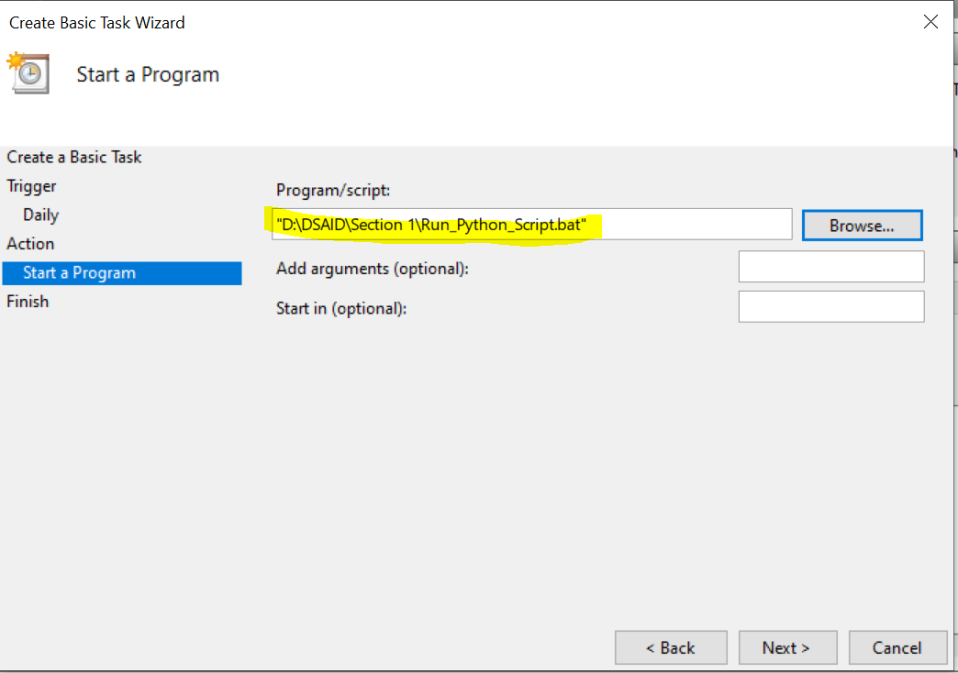

*Step 7*

*Finally, click on****Finish****, and you should be good to go:*

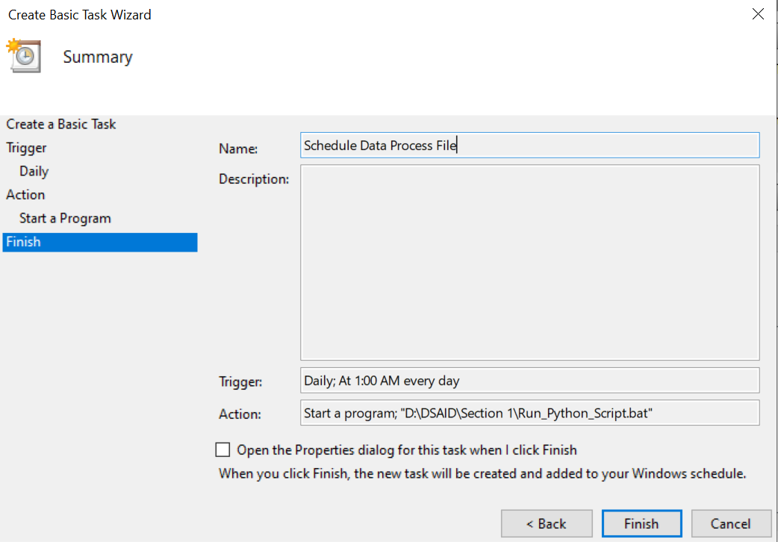

*From this point onward, the file will be processed every day at 1am, In this example dataset.csv is used for the file to be processed.*

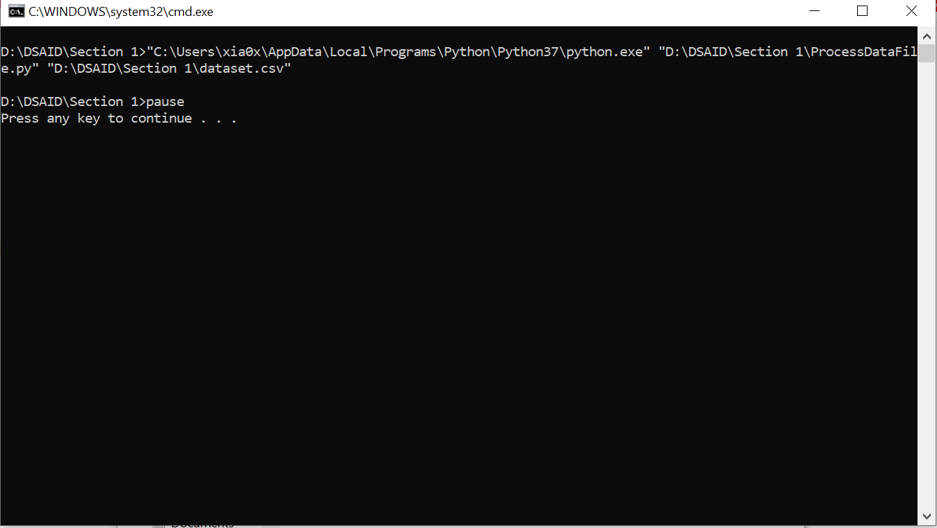

# Linux OS

## Schedule the execution of Python Script using CrobTab

*The general structure of a crontab command is detailed below:*

* The first * is minute, if you set this to 5, the job will run every 5 minutes, leaving all the other * values as 5 ****. Minutes ranging from 0 to 59.
* The second * is for hour, ranging from 0 to 23
* The third * is for day of month, ranging from 1 to 31
* The fourth * is for the month, ranging from 1 to 12
* The fifth * is for day of the week, ranging from 0 to 6, with 0 being Sunday

* * * * * cd /WORKING DIRECTORY/ && /LOCAL PYTHON PATH/ /WORKING DIRECTORY/py_script.py && /WORKING DIRECTORY/dataset.csv

*A script that runs every day at 1:00AM local time:*

0 1 * * * cd /Users\user.name/DSAID/Section 1 && /usr/local/bin/python /Users/user.name/DSAID/ProcessDataFile.py && /Users/user.name/DSAID/dataset.csv